YOU’RE INVITED:
Kasper’s Pedestrian Plaza Design Meeting & Survey

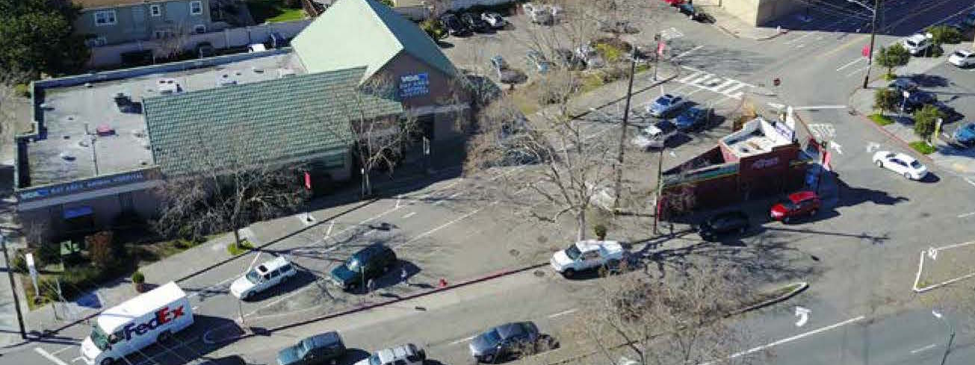

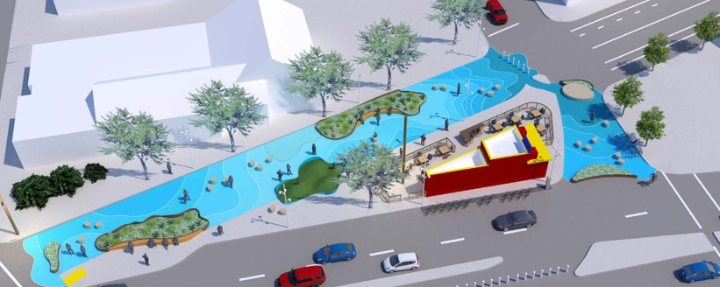

- Online survey: https://www.surveymonkey.com/r/KASPERS
- In-person meeting: Tuesday, April 3rd

Please join the Temescal Telegraph Business Improvement District (TTBID) and Groundworks Design for a presentation of the TTBID's proposal to create a pedestrian plaza at Kasper's, including the existing sidewalk, Shattuck Ave from 45th to 46th, and the 46th St slip lane (Telegraph to Shattuck). Groundworks will present the various concepts and themes for the plaza, listen to your comments, receive feedback and answer questions. As part of the community, from businesses, property owners, and residents, your opinion matters! We want this plaza to be a vibrant and welcoming community gathering spot.

The purpose of this pedestrian plaza is to significantly improve traffic, bike and pedestrian safety, and create a welcoming public gathering place for the Temescal community. The Temescal BID is seeking a vibrant public plaza design that will function well despite the currently inactive state of the adjacent Kasper's building, and also complement a food business that may operate in that building. Elements to be considered include but are not limited to seating, tables, temporary and/or permanent art, plants, and a play area for children.

